Please see this weeks update.

For ease of reading all significant updates are highlighted in red.

Works have been progressing this week with 112m of public and private sewer lined.

Progress Update:
- The total sealed to date is 13,499m across both public and private sewer networks.

We continue to have 2 manhole sealing teams in the Lavant valley between East Dean and West Dean.

Whilst also having our contractor MTS checking the condition of the sewer sealing in the same area.

As of yet we have not found any issues with the sewer sealing material installed. We have however located some manholes that are still allowing ground water to infiltrate into the wastewater system, these will be dealt with accordingly as manhole team are onsite.

Aside from the above, it’s business as usual as we continue progressing with the task at hand.

I've also included the borehole data from Chilgrove below which shows the ground water levels for your reference.

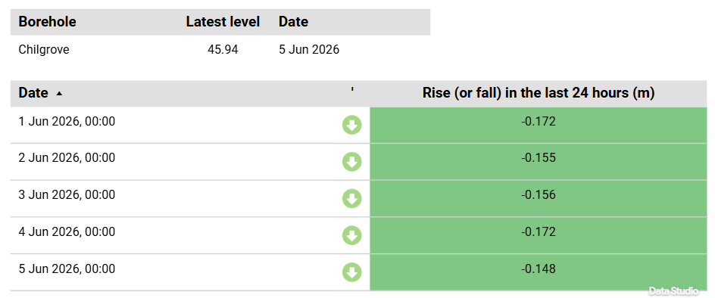
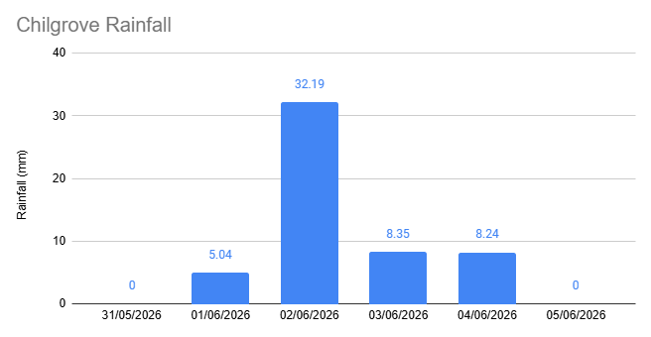

The ground water continues to fall and we will monitor this to find more localised issues created by this years ground water season.

